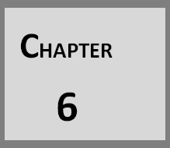

**DATA DICTIONARY**

**6.1 Data Dictionary**

E:\Capture33.PNG**Chapter 6 Data Dictionary**

#### 6.1 DATA DICTIONARY (Database Structure)

* **Wallet Database**

***Fig 6.1:- Wallet Database***

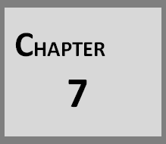

**IMPLEMENTATION PLANNING**

* 1. **FUNDAMENTAL OF SOFTWARE IMPLEMENTATION**
  2. **SECURITY FEATURES**
  3. **CODING STANDARDS**

## E:\Capture33.PNGChapter 7 Implementations Planning

#### FUNDAMENTAL OF SOFTWARE-IMPLEMENTATIONS

They are relatively easy to learn and use: .The user uses multiple screens for system interaction. Switching from one task to another is possible without losing sight of information generated during the first tasks. Fast full screen interaction is possible with immediate access to anywhere on the screen. Good user interface design is critical to the success of a system. An interface that is difficult to use it at best result in high level of user errors. At worst users will simply refuse to use the website irrespective of its functionality. If information is presented in confusing or misleading way user may misunderstand the meaning of information.

The system which we have developed is the client server application with Multi User facility and it is GUI based. Here four possibilities are there.

* + 1. Single user and GUI
    2. Single user and Non GUI
    3. Multi user and GUI
    4. Multi user and Non GUI

##### Single user and GUI:

Single user means at a time one user use the system and satisfied with the GUI of the system means designing part has been implemented as per the client satisfaction.

##### Single user and Non GUI:

Here in this possibility, single user means at a time one user use the system and Non GUI means features as well as all functionalities of the system have been implemented as per the client satisfaction.

##### Multi user and GUI:

Multi user means at a time more than one user use the system from any place(through online) by their own USB lock, User name and password which have

been given from the company and satisfied with the GUI of the system means designing part has been implemented as per the clients satisfaction.

##### Multi user and Non GUI:

Multi user means at a time more than one user use the system from any place(through online) by their own USB lock, User name and password which have been given from the company and Non GUI means features as well as all functionalities of the system have been implemented as per the client satisfaction.

#### SECURITY FEATURES

##### Form Based Authentication:

Only Admin is authenticated to create new user, select user type, Add organization details and Application details.

##### Initially Must be Login:

Only Authenticated users are allow to add and update rules.

##### Path of the Assembly is encrypted

Other Users of the system except Admin cannot know where the .dll files reside. All the users of the system Compulsory have to pass from the login form. For login with user name and password. If Username/Password will not match the person could not enter into the system.

Every User has assigned the rights or role for access the system. So another department person could not access the different department. The Duplicate Entries are prohibited on this application so the Conflict username could not be possible I this application. The database of this system is also password protected from the admin side on the

Company’s server so no one can modify the database.

#### CODING STANDARD:

Majority of the programmers write 'working code', but not „good code'. Writing 'good code' is an art and you must learn and practice it. Everyone may have different definitions for the term „good code‟. The following are the characteristics of good code.

**Reliable Maintainable

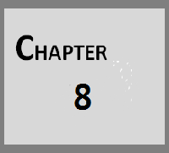

**INPUT AND OUTPUT DESIGN**

**8.1 SCREEN LAYOUT**

## Chapter 8

E:\Capture33.PNG**Input And Output Method**

#### 8.1 SCREEN LAYOUT

#### 

##### Landing Page

##### *Fig 8.1:- Landing Page*

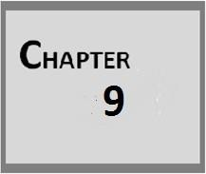

**LIMITATION AND FUTURE ENHANCEMENCTS**

* 1. **LIMITATIONS**
  2. **FUTURE ENHANCEMENTS**

## Chapter 9

E:\Capture33.PNG**Limitation And Future Enhancements**

#### LIMITATION

Though we tried our best but due to some reasons like time available the system has some limitations as compared to the other content providers. Since these limitations can be easily removed. Here we will discuss these things

* All the page and database are stored at server side so if server goes down then system cannot respond.
* Customer can change only their personal information themselves.
* There is no downloading or uploading.
* The system requires browser to run.
* Web Application requires internet connection for entire operation. There is no offline mode

#### ADVANTAGES

* DA will provide Fast Money Transactions.
* DA will provide Safe and Secure Transactions.
* All the information Of the is Going to Private Only Accessible By Authorized User Only.
* Users will be able to securely login to the DA system.
* DA will have standard security features which will prevent unauthorized access to the portal.
* Users will not have to install any additional software’s to access DA.
* DA will be user-friendly, understandable and easy to use.

#### FUTURE ENHANCEMENT

Each and every system contains scope for better developments. It means that each and every system has enhancement possibilities. In our project enhancement can be made like:

* Optimization to output the results rapidly.
* At last, In Future we will try to provide better & better design to our application.
* And, we try to provide better and better service to customers.

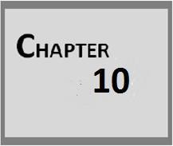

**CONCLUSION**

**10.1 CONCLUSION**

## E:\Capture33.PNGChapter 10 Conclusion

#### 10.1 CONCLUSION

Persons don't have complete knowledge regarding all products. They need accurate information available to them instantly in order to choice best products. The user should be aware of all the products options if they make a particular choice of good marketing.

Thus DA is a app-enable service that can be accessed from anywhere in the world through the internet. DA will provide all the information related to the good products. It will guide persons to choice better by selecting the right one.